DBOX Multi Level BOM Search
POST – https://stresscretetest.dboxnow.com/api/Search

JSON Body Sample
{
"id": 61,
"skip": 0,
"take": -1,
"columns": [
{
"searchDetailId": 2778,
"name": "RootItemNo",
"rowKey": "rootitemno",
"dataType": "0",
"formatMask": null,
"sortOrder": null,
"position": 3,
"fieldType": null,
"appliedFilter":
{
"from": "05X01FG4K5Y7E09XX01",
"to": null,
"dataType": 0,
"type": 1,
"name": "Equals/Between",
"isExcluded": false,
"sFieldAlias": null,
"fromEnabled": true,
"toEnabled": true,
"fromLabel": "dynamicGrid.textBetweenFromLabel",
"toLabel": "dynamicGrid.textBetweenToLabel"
},
"summaries": [],
"appliedSummaries": null,
"display": true
}
]
}

Passing in a value of -1 for the take will return all results. Be sure when using this argument that you do have a column with an applied filter. The JSON Body above should work immediately with the URL above. However, I can also explain how I built this request just so you can have a deeper understanding of Search.
The first thing to note, is the id. The id of 61 just identifies which search we want to use. A search is basically just a user defined SQL Query that we can interact with. I created the Search through the OrderStream interface, and then grabbed the ID for use with the API.
If we want to see what the search returns without a filter, we can call the following API:
GET – https://stresscretetest.dboxnow.com/api/Search/61
Note the ID of 61 is used as a parameter. This will return the first 15 rows of data, ordered however the query/search was configured in OrderStream.
The response of this query will return a data structure that we can re-use with the POST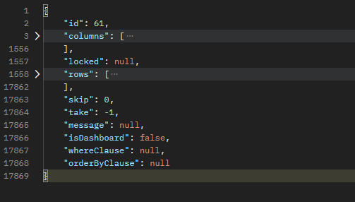
The columns array is a list of all the columns returned by the search. These columns also include a list of filters you can use to get more detailed results. In my POST example above, I located the RootItemNo column, and the “Equals/Between” filter. I then copied that JSON object into the AppliedFilter parameter of the same column. I entered my RootItemNo I wanted to filter by in the “from” field of the AppliedFilter.
As you can see by the size of the response from the GET above, you can omit a large amount of the data when using the POST to send data returned from the GET to retrieve filtered results. There is never any reason to return the rows to the POST, and you can also omit any columns that you aren’t using to filter.
A quick note, the data returned by this call may not be perfectly accurate, if you approve us to go forward with creating a dedicated API call to retrieve Item BOMs and Labour we would create a dedicated response object that would be very different from the Search above, so don’t plan on designing your solution around this object.

